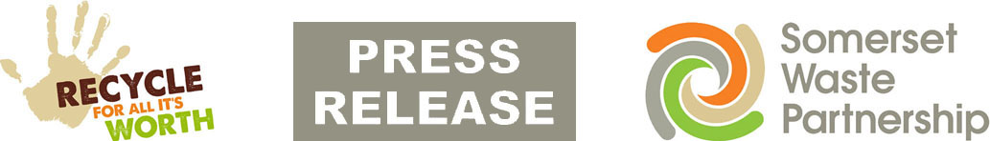

5 June 2020

Recycling sites: plastics and wood taken from 8 June

Somerset's recycling sites will accept more materials from next week.

From Monday 8 June, all 16 sites will take plastic pots, tubs and trays; waste wood (man-made or natural); small household electrical items (such as toasters); and paint.

This is as well as the other materials already being accepted as the service moves back towards business as usual after sites were closed due to COVID-19.

Please remember, any items you would usually pay to have disposed of will not be accepted, such as commercial waste, tyres, gas bottles, soil and hardcore, vehicle parts, plasterboard and asbestos.

All sites are now open for their usual summer hours and the odd and even number plate access system is no longer in place.

Please check www.somersetwaste.gov.uk/recycling-centre-queue-cams before you leave to see the queue cams for Bridgwater, Chard, Highbridge, Minehead, Street, Taunton, Wells and Yeovil.

Somerset Waste Partnership (SWP) is advising people only to come to the sites if they really need to. Long queues are expected, especially first thing in the morning, as the number of unloading bays has been reduced to allow social distancing. Other access restrictions remain in place:
- Maximum of two people per household
- Gloves must be worn
- Strict social distancing
- Trailers and 3.5 tonne vans only allowed access 4pm-6pm weekdays.

Mickey Green, Managing Director at SWP, said: “This is another big step forward and we thank everyone for their continued patience and understanding. Social distancing measures will remain for the foreseeable future, so the advice remains to only come if you really need to because you may find yourself facing a lengthy wait.

“We’re all trying to get back to as close to normal as possible, and in Somerset that means great recycling. Most people in Somerset recycle and that helps protect our environment and tackle climate change. Recycling everything you can and making sure it’s properly sorted into the containers helps us reuse and recycle more than 130,000 tonne of waste each year, of which more than 90% stays in the UK.”

The full list of materials taken at Somerset recycling sites from Monday:
- Rubbish – material you would usually put in your black rubbish bin, excess black bags not taken by kerbside collections (landfilled in Somerset)
- Bulky items, such as furniture and mattresses (landfilled in Somerset)
- Garden waste (composted in Somerset)
- Large household electrical items – white goods, TVs etc (recycled in UK)
- Small household electrical items – irons, toaster etc (recycled in UK)
- Hazardous household chemicals, such as solvents, garden chemicals, paint thinners and antifreeze (treated and disposed of in UK)
- Cooking oil and engine oil, in disposable containers of up to five litres (recycled in UK)
- Scrap metal (recycled in UK)
- Plastic pots, tubs and trays (recycled in UK)
- Paint (water-based recycled in UK; other paint landfilled)
- Man-made wood - chipboard, MDF, etc (recycled in UK)
- Natural wood - untreated timber, tree trunks, etc (recycled in UK)

Access to most recycling skips is not possible. Unless you really need to, please do not bring materials that can go in the continuing weekly recycling collections (these will temporarily be landfilled): www.somersetwaste.gov.uk/recycling-collections.

Visit www.somersetwaste.gov.uk for more about how to reduce and reuse your waste. Visit www.somersetwaste.gov.uk/coronavirus for the latest information about services and any disruption, and follow @somersetwaste on Twitter and Facebook.

[END]

Notes to editors
Please find attached an image which sets out the summer opening hours for all sites.

Somerset Waste Partnership manages waste services for all councils in Somerset.

Media contacts:
- Mark Ford, Head of Communications and Engagement, 07977412198 mford@somersetwaste.gov.uk
- Senior Communications Officer Nick Cater news@somersetwaste.gov.uk

